Prepared by: Erwin (2019-05-19)

# Reports for Test for Data Visualization Engineer (Biofourmis)

### A. Data Visualization / Data Cleaning Preparation

The first thing that came to my mind when I saw the project was that this looks extremely familiar. I must have seen it somewhere in my LinkedIn news feed before.

Upon further digging with some keywords like “visualization”, “timeline”, “daily life”, I saw the post from [Nathan Yau’s “A Day in the Life of Americans” in Flowing Data](https://flowingdata.com/2015/12/15/a-day-in-the-life-of-americans/).

After viewing the page source and understanding some part of the script from Nathan Yau’s article, I start to tweak around the script and data to see how it reads and parse the data to the visualization.

It seems that the raw data (data/raw/activity.txt) needs to be transformed, so that it can be fed easily into the existing script.

So, I used some python script (ETL/timeuse-simulation.py) to aggregate the person and activities into a list of key-value pairs, e.g. [{ “person1”: “Act1, 20, Act2, 30, Act3, 60”}, { “person2”: “Act1, 20, Act2, 30, Act3, 60”}].

After that, I modified the existing javascript to read from the key-value pairs of person and activities (data/cleaned/activity_cleaned.json) instead of the dummy list in the existing data.

After a few more tweak for the time changes, and the activity categorization in the scripts, I proceed with noting down the insights obtained from the observation of the visualization.

Below are the insights/ conclusion from the visualization that I have observed.

### B. Insights / conclusion from the clustering changes on the timeline.

#### 12:00 am to 01:00 am

Most people are sleeping at these hours. Some poor souls are still commuting back from work.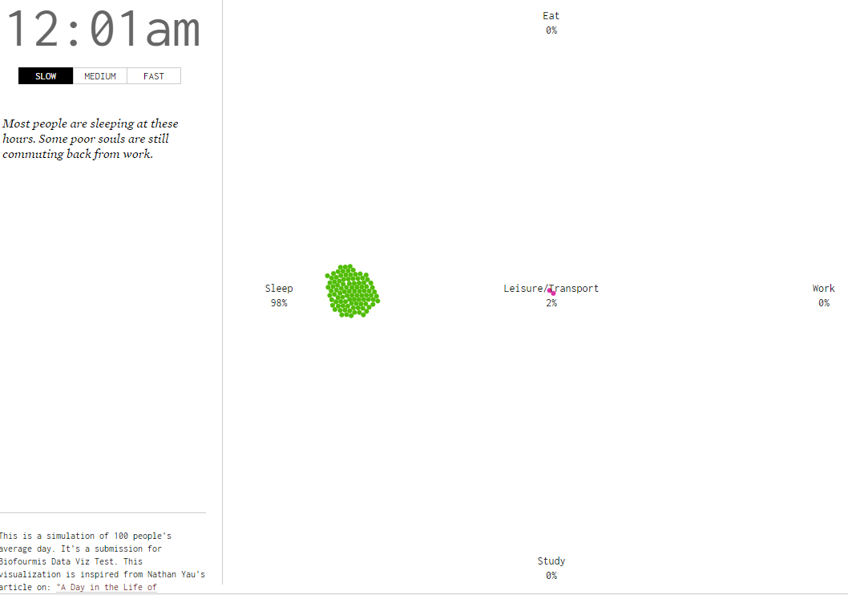

#### 01:00 am to 04:00 am

Finally, even the night owls are asleep right now. Good night. 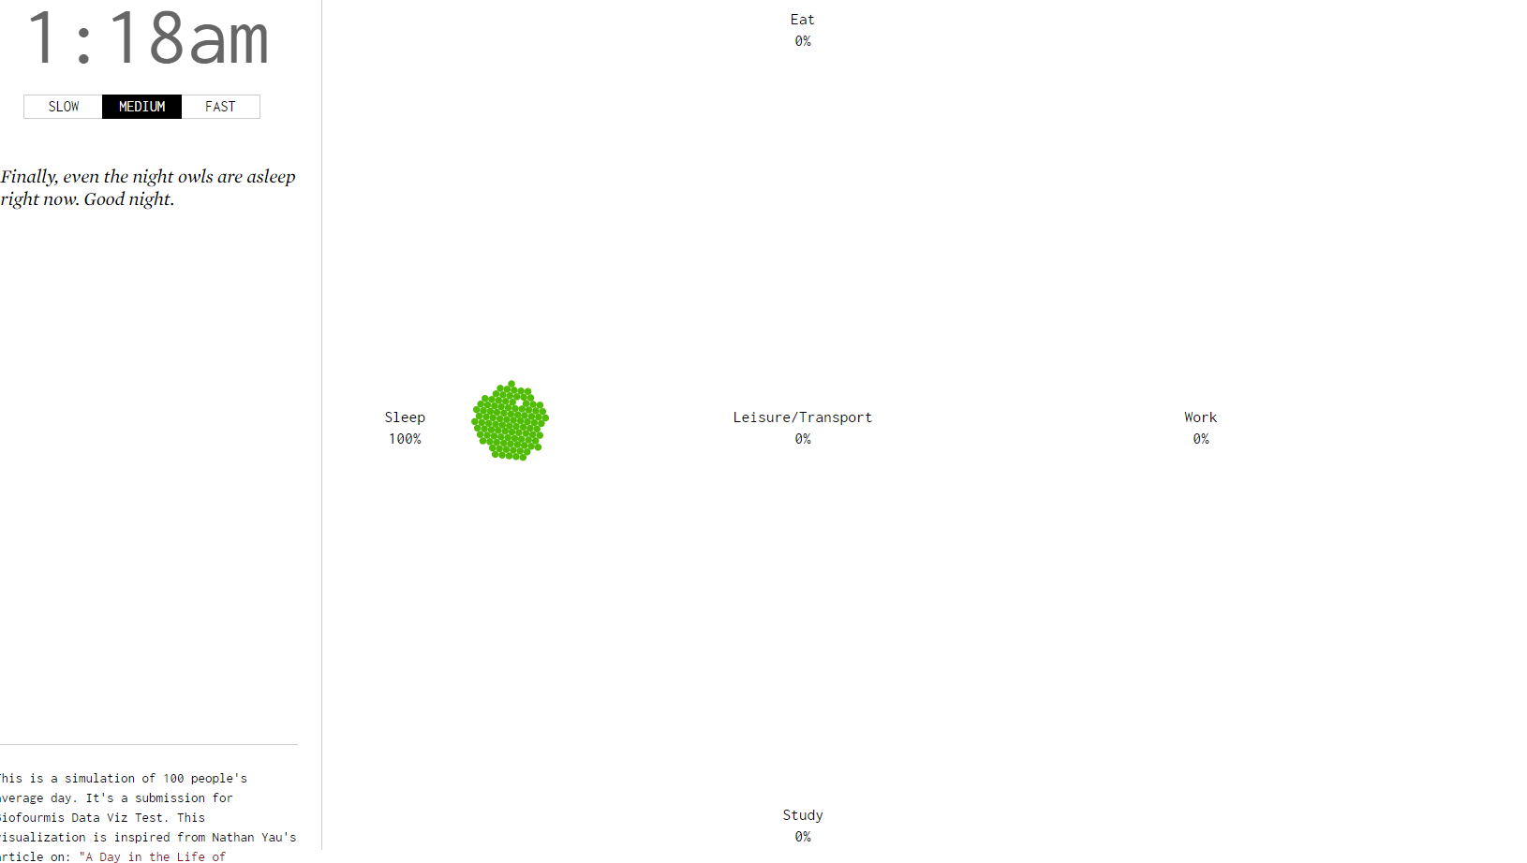

#### 04:00 am to 06:00 am

We can see people start waking up for early breakfast. Interestingly, some of them goes back to sleep.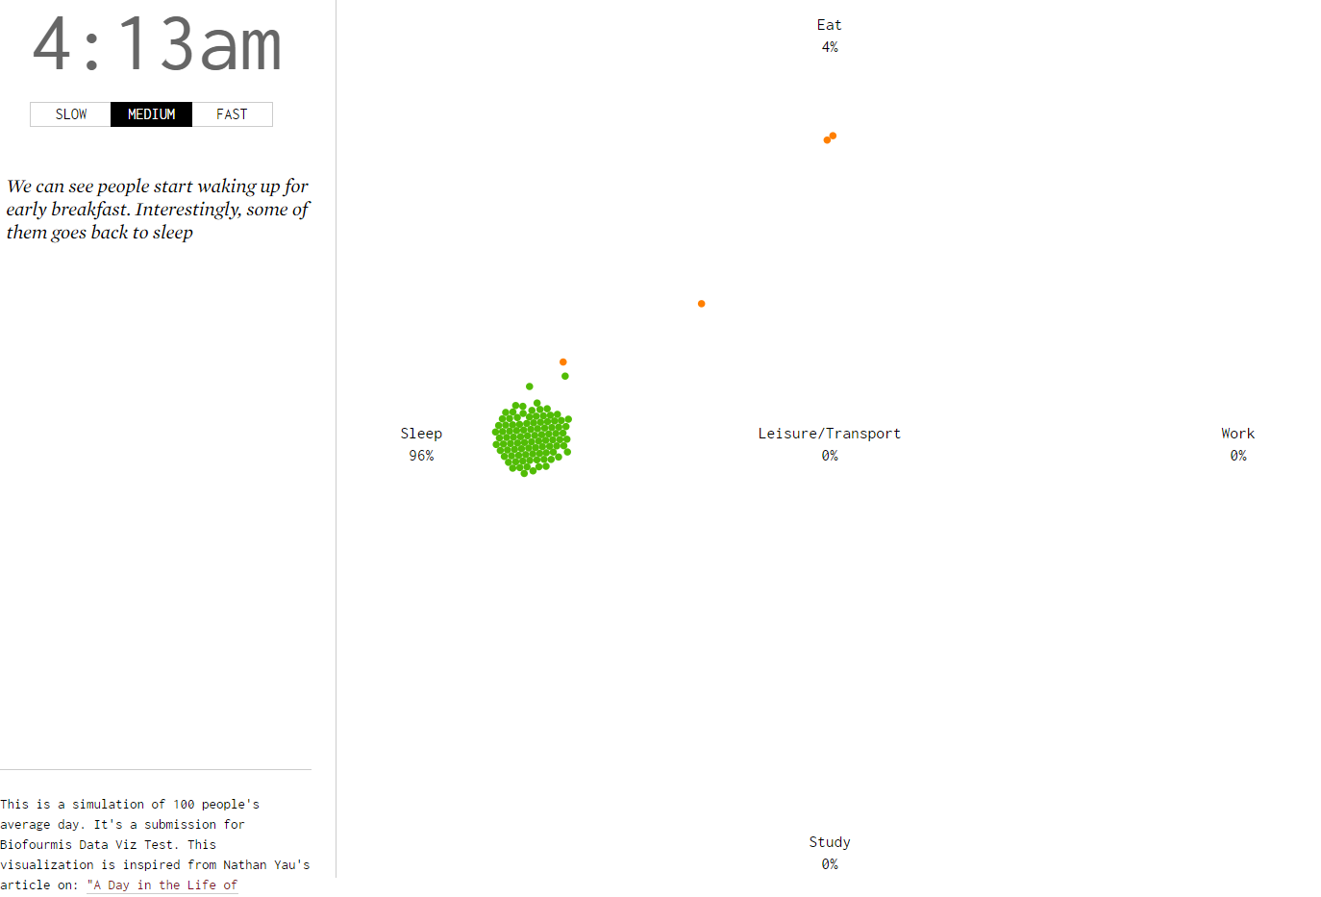

#### 06:00 am to 08:00 am

After breakfast, people start commuting to work / school.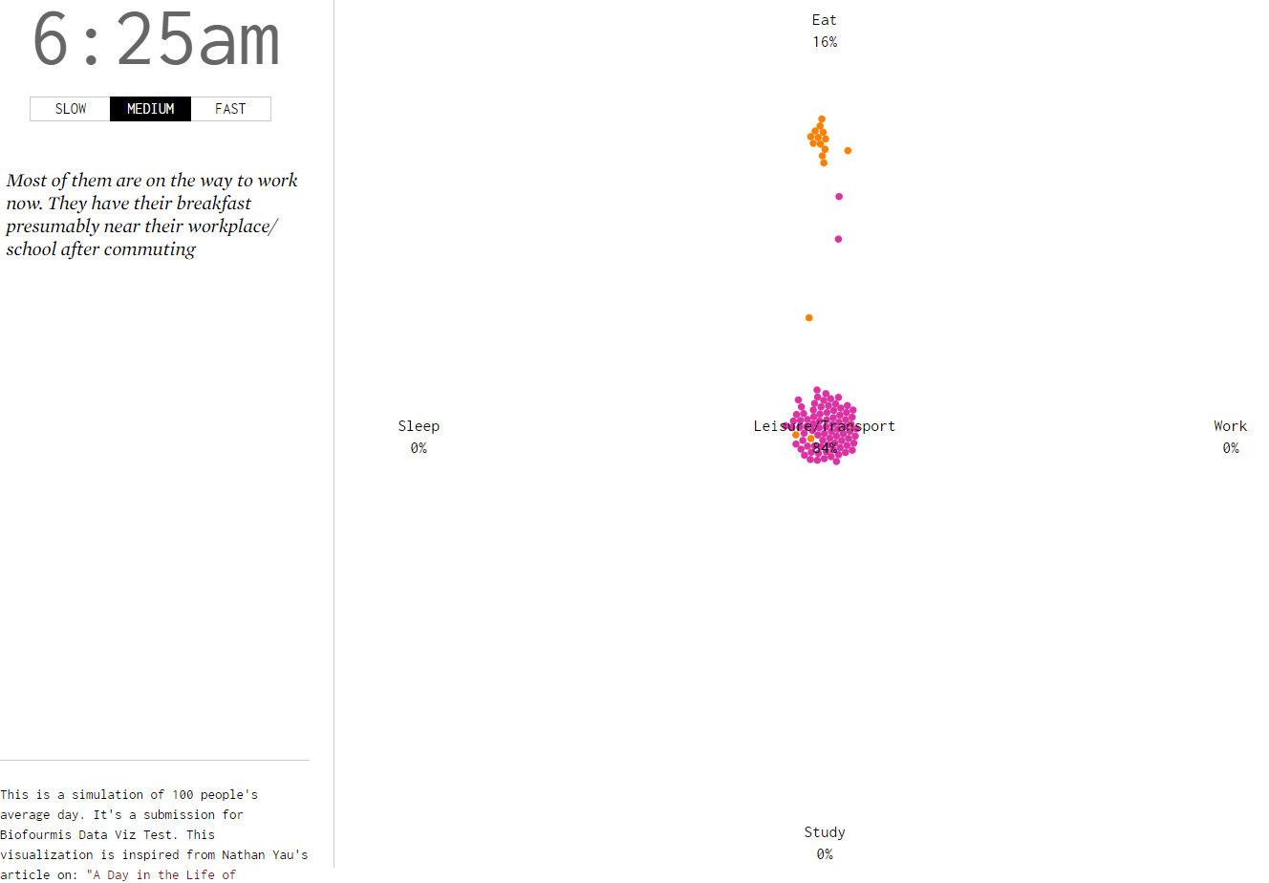

#### 08:00 am to 09:30 am

It's time to start working! School bell starts ringing as well! 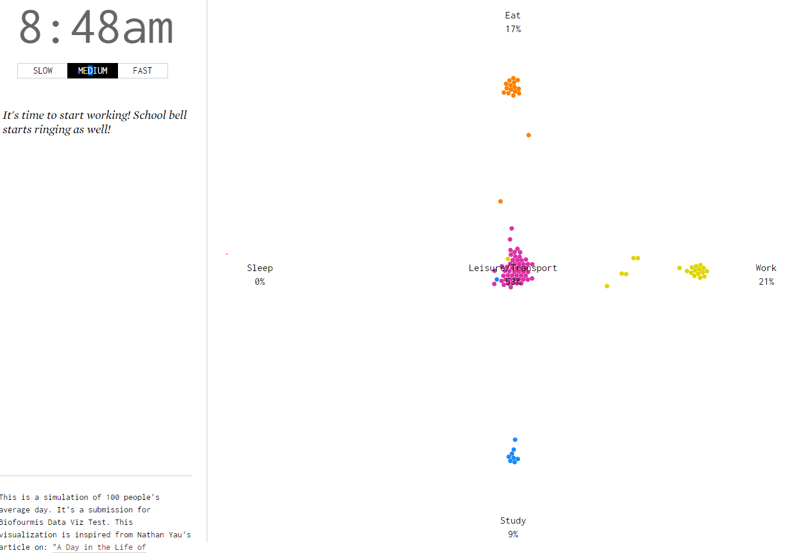

#### 09:30 am to 11:00 am

Interestingly, some of them goes for breakfast or coffee / tea break after doing some work / study in the morning.

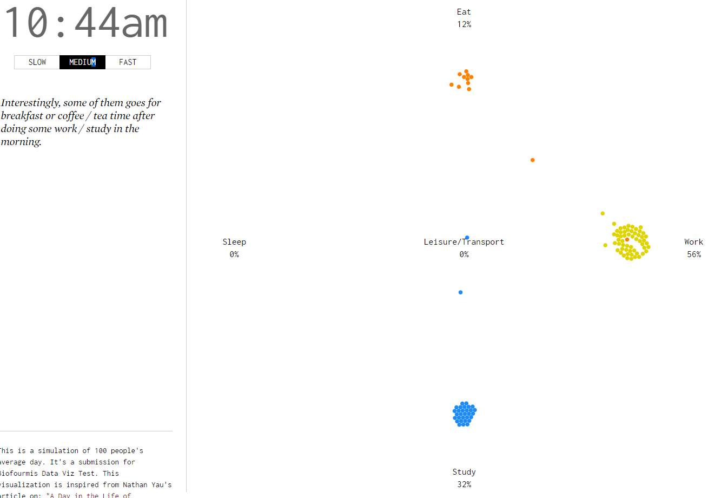

#### 11:00 am to 02:00 pm

It's lunch time. Interestingly, the crowds don't go for lunch at similar time slot.

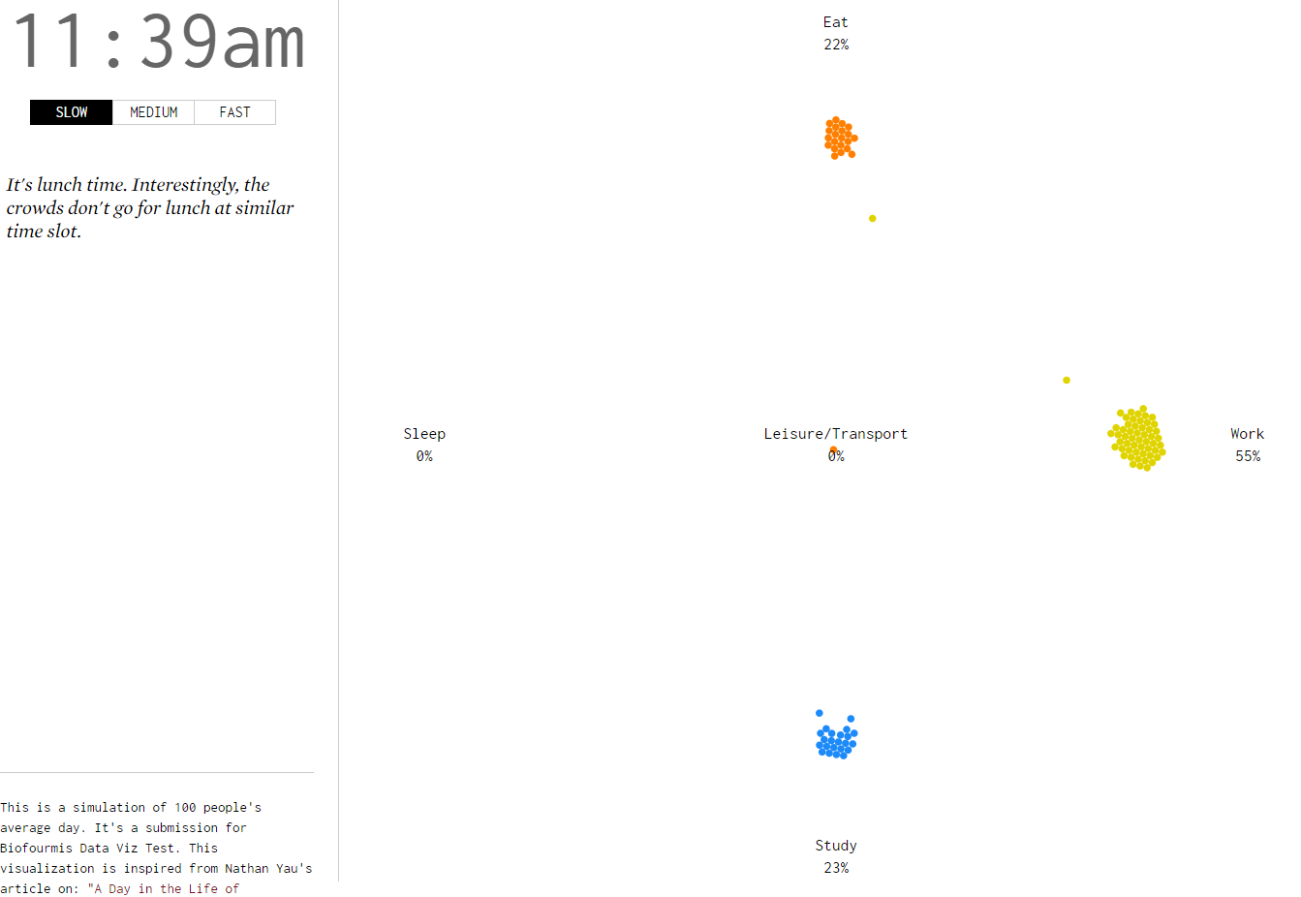

#### 02:00 pm to 04:00 pm

After lunch, some students / professionals have leisure break / commuting. Others continue working / studying. Small group of people are still having lunch or afternoon tea break.

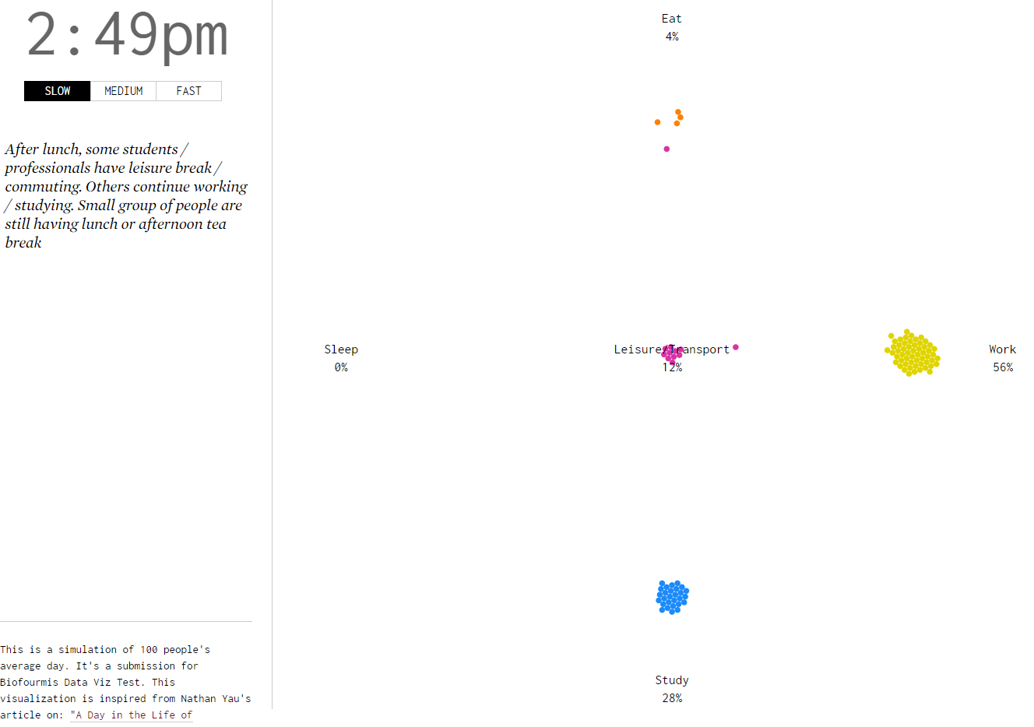

#### 04:00 pm to 06:00 pm

The crowds start to swarm in for the evening commute back to home / places for dinner.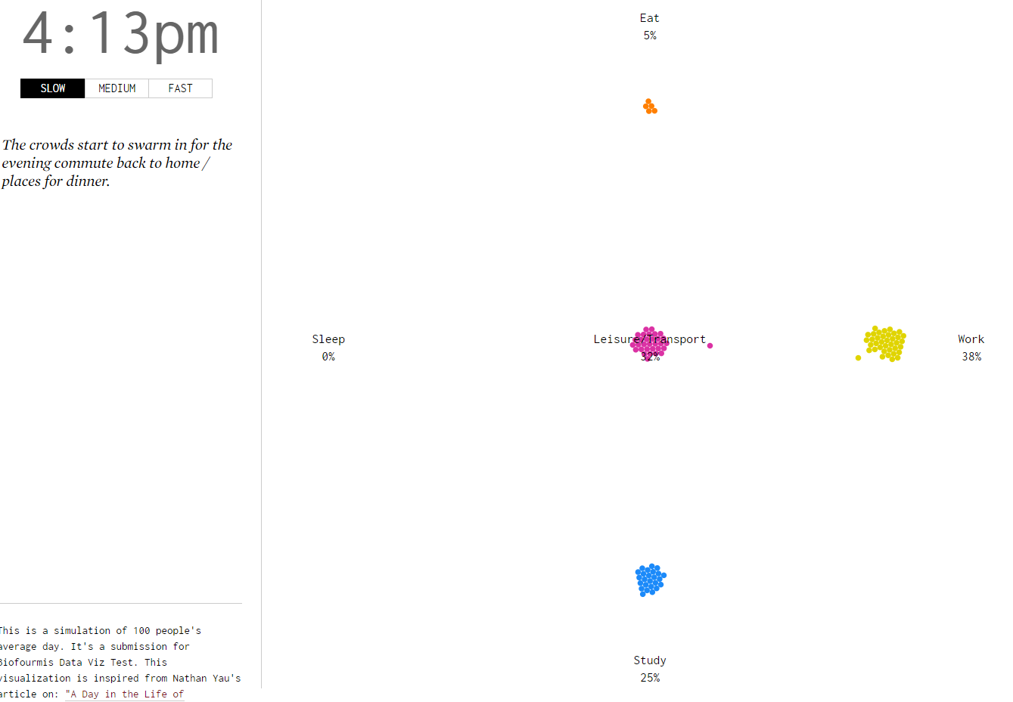

#### 06:00 pm to 08:00 pm

It's dinner time! People start to go for their dinner, while some hardworking people are still enjoying their work/ study.

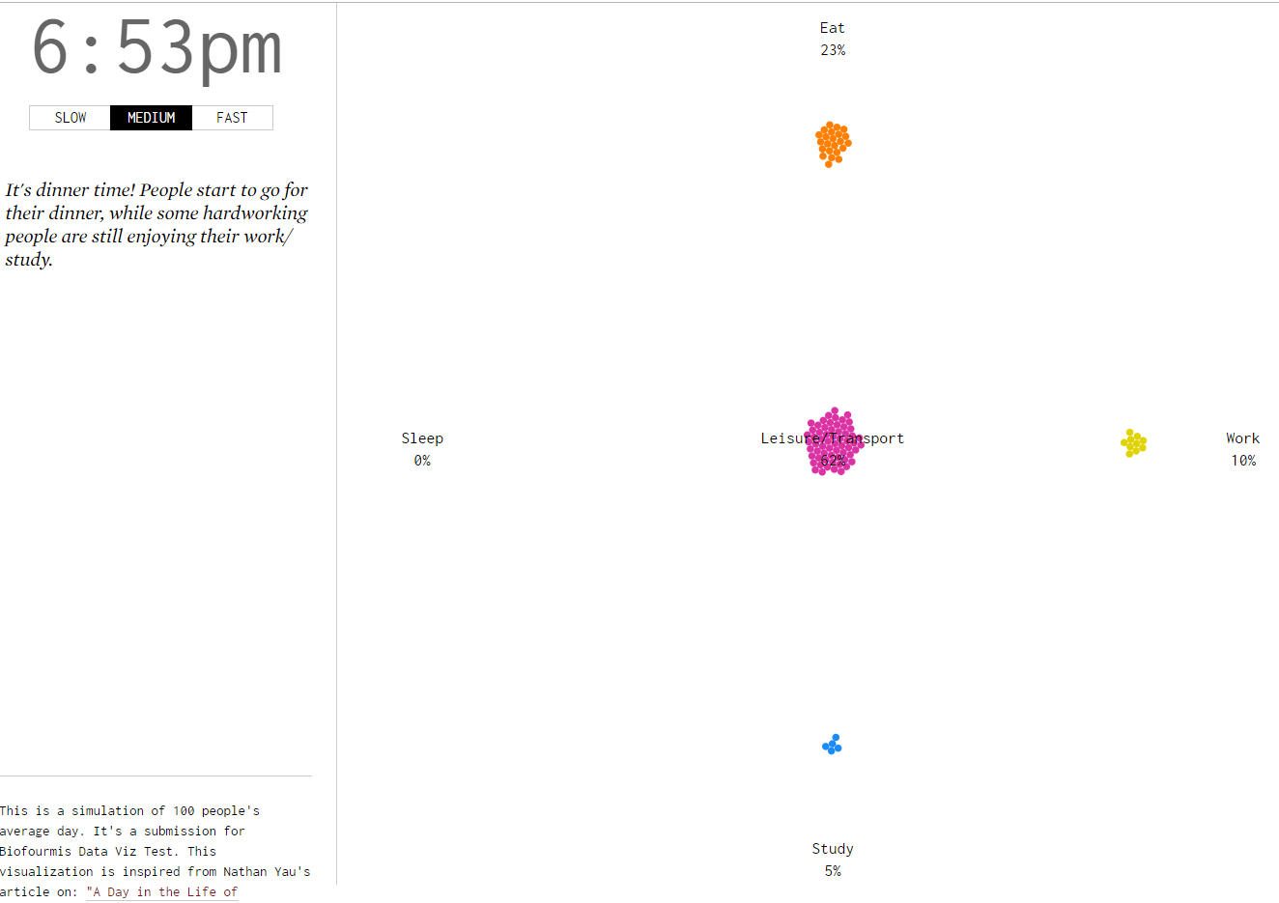

#### 08:00 pm to 10:00 pm

After dinner, most of the people are in their leisure activities/ commuting back home. Some professionals are still hustling at work.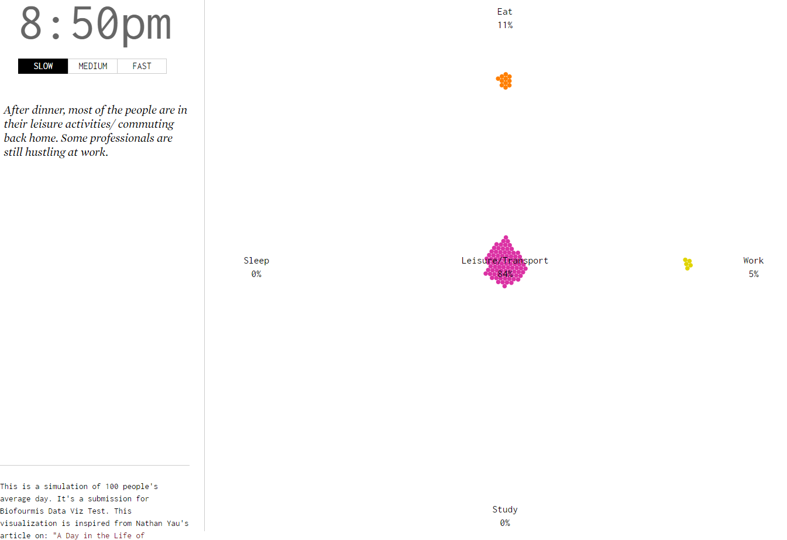

#### 10:00 pm to 11:59 pm

The crowds are starting to head to their bed. Interesting observation: people are still eating at these late hours.

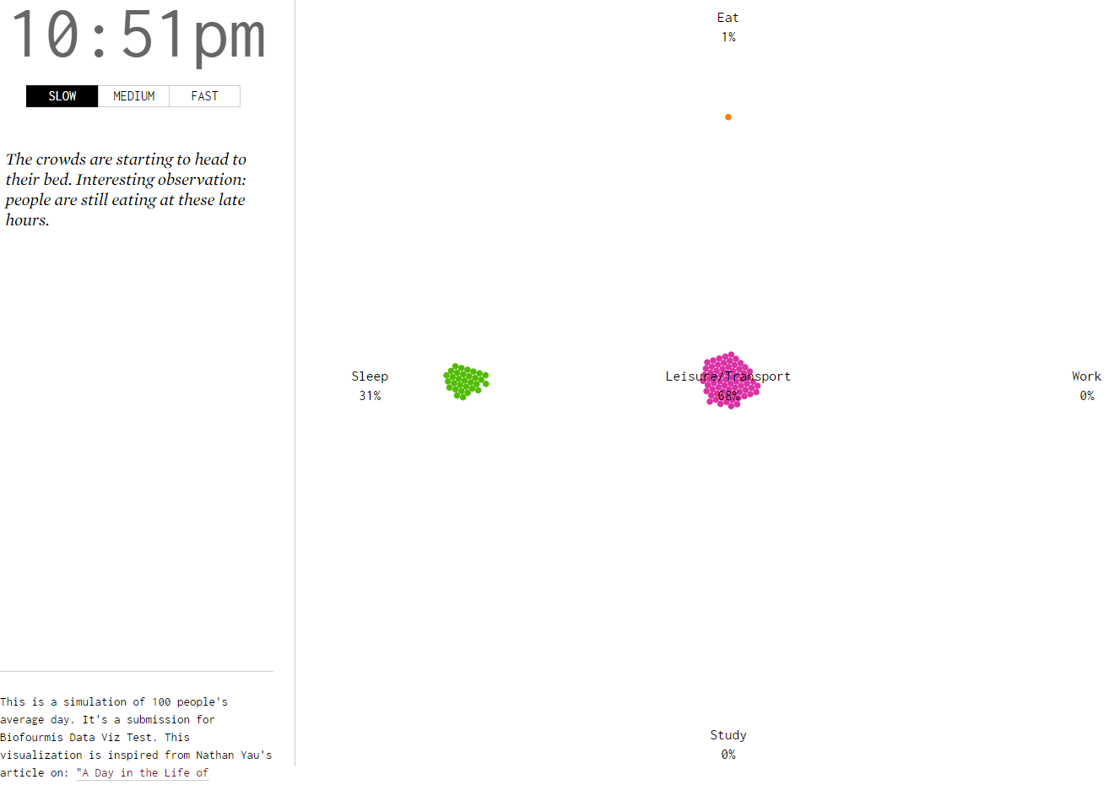

### C. What can be concluded from the 'Sleeping' of given population? what kind of health habits can be inferred from the data?

1. People seem to have a lack of sleep, presumably sleeping around 6 hours in average. From the graph in section B, we can see that the earliest batch to start sleeping is at around 10pm, but they woke up earliest at around 4 am. This is only around 6 hours of sleep!
2. Those who wake up at around 4 am goes back to sleep again after their early breakfast. This is not good for their health and probably leads to obesity in the long run.
3. As shown from the graph in section B, people are having irregular eating time. We can see that the meal time is irregular across the sample data. Some of them have very early breakfast, but some others eat near their workplace after commuting. The lunch time pattern is also spread from around 11am to around 2/3pm. For dinner, there are still people eating at around 10pm!
4. Long working hours. This probably leads to insufficient sleep as well. We can see that people are still working at around 9/10pm. There are even people still commute at around 12 midnight.